The Miner's Spice Restaurant Platform
Full-Stack Restaurant Website, Online Ordering and Administration System
Project Documentation in IEEE-Style Report Format
Muhammad Haider Abbas
MSc Computer Science and Technology, Ulster University Birmingham Campus
Birmingham, West Midlands, United Kingdom
Live Project: https://theminersspice.co.uk/
Abstract— This documentation presents The Miner's Spice Restaurant Platform, a business-focused web system designed to support a real restaurant with online visibility, digital ordering, guest table reservations, menu presentation, customer communication and administrative workflow management. The live public website provides core pages for home, menu, order online, table booking, gallery, contact, allergens, login and sign-up. The system is positioned as a practical hospitality digital transformation project: it reduces friction in customer ordering and booking, gives restaurant staff a more structured operational channel, and improves trust through visible opening hours, location details and allergen guidance. The report documents requirements, system architecture, database design, data flow, security considerations, testing strategy, deployment model, limitations and future enhancements. The project demonstrates applied full-stack web development, user-experience design, database-driven content handling and commercially relevant restaurant workflow automation.
Keywords— Restaurant management system; online ordering; table booking; PHP; MySQL; Stripe Checkout; CMS; hospitality platform; responsive web design; food allergen information.

I. INTRODUCTION
The Miner's Spice Restaurant Platform is a live restaurant web application developed to give a local hospitality business a professional digital presence and a structured operational workflow. The homepage identifies the restaurant as The Miner's Spice and presents the core customer actions of ordering online and booking a table. The live site also communicates business information such as opening hours, delivery radius, address, phone number and customer review messaging. The project therefore combines marketing, customer service, e-commerce ordering and administrative management into a single practical web platform.
Unlike a simple brochure website, this project is designed around transactions and restaurant operations. Customers can explore the menu, filter dish categories, add products to a basket, reserve tables without account creation and access allergen guidance before ordering. The admin-side objective is to provide restaurant staff with maintainable control over content, bookings, orders and general website settings.
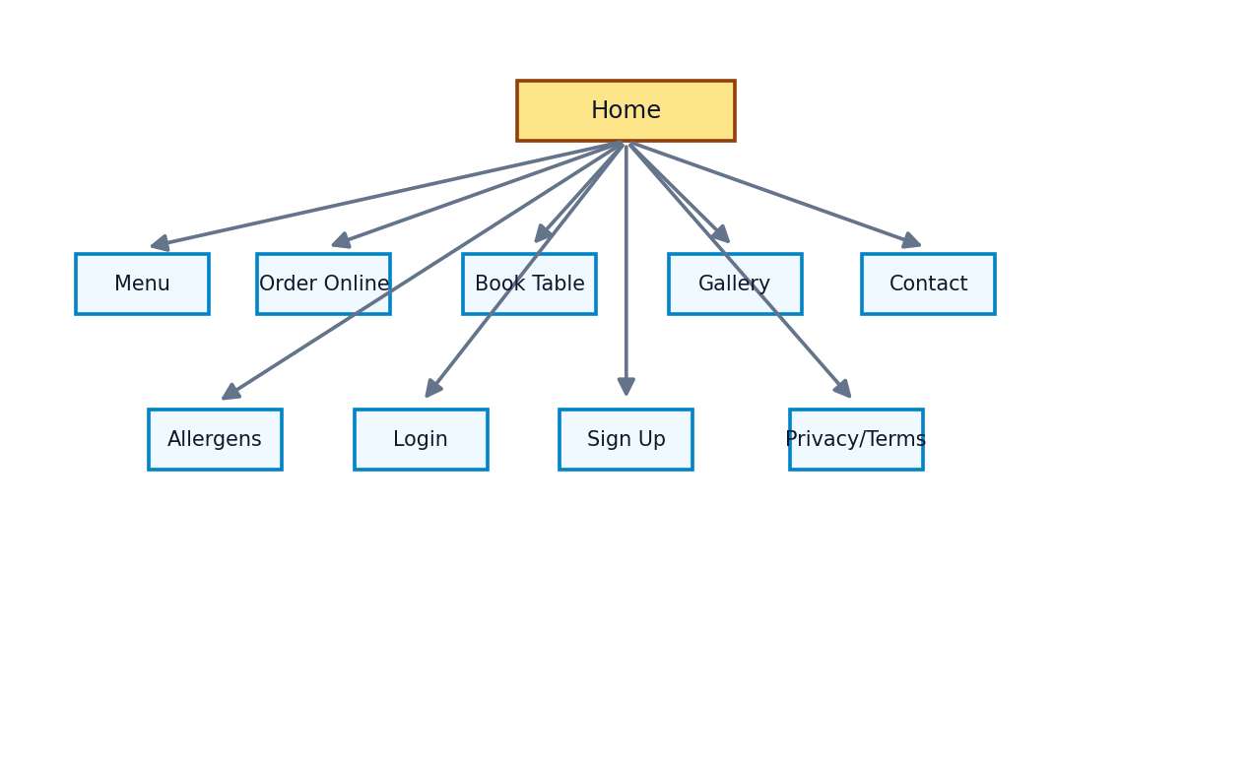
Fig. 1. Public website sitemap derived from the live navigation structure.

II. PROJECT BACKGROUND AND BUSINESS CONTEXT
Restaurants increasingly depend on direct digital channels to reduce dependence on third-party ordering platforms, improve customer retention and communicate timely operational information. The Miner's Spice is positioned as a classic-modern dining and celebration space. The homepage describes it as a calm, classic-modern space for dining and celebrations and highlights ordering, booking, allergen information and live tracking style features.
The business is publicly presented at Hermitage Park Hotel, Whitwick Road, Coalville LE67 3FA, with a listed telephone contact of 01530 814814. The live site states Monday to Saturday opening hours from 17:00 to 23:00, Sunday closure and an eight-mile delivery radius. These public data points demonstrate that the system is intended to support real local restaurant operations rather than act as an abstract demonstration.
Business Element | Observed/Planned Value
Restaurant name | The Miner's Spice
Domain | https://theminersspice.co.uk/
Location | Hermitage Park Hotel, Whitwick Rd, Coalville LE67 3FA
Phone | 01530 814814
Public services | Menu browsing, online ordering, table booking, gallery, contact, allergen page
Operational focus | Customer acquisition, order handling, reservation workflow, content management

III. PROBLEM STATEMENT
The restaurant required a digital system capable of serving customers before, during and after their dining decision. Typical restaurant websites often fail because the menu is static, reservations require phone calls only, the ordering process is disconnected from administration and allergen communication is hidden or incomplete. For a local restaurant, this can lead to missed bookings, manual order handling, inconsistent menu updates and reduced customer confidence.
The problem addressed by this project is therefore the design and implementation of a unified restaurant platform that connects customer-facing pages with management workflows. The platform must remain simple enough for restaurant staff to maintain while providing enough structure to support ordering, booking, content updates and secure customer-data handling.

IV. AIM AND OBJECTIVES
The aim of the project is to develop a modern, responsive restaurant platform for The Miner's Spice that supports public information, menu discovery, online ordering, table reservations and administrative management.
1. Design a professional, brand-consistent public website for The Miner's Spice.
2. Provide a categorized menu and online ordering interface with basket functionality.
3. Implement table booking without forcing customers to create an account.
4. Support admin management of menu content, orders, bookings, gallery/media and settings.
5. Provide clear allergen and contact information to improve customer trust and operational safety.
6. Apply secure development principles for authentication, validation, payment handling and personal data protection.
7. Document the project using an IEEE-style structure with requirements, design diagrams, testing evidence and future enhancements.

V. SCOPE OF THE SYSTEM
The system scope includes the public web interface, restaurant content management, menu and category management, cart/order flow, table reservation flow, contact workflow, allergen information and administrative tools. The scope does not claim to replace a full enterprise-grade EPOS platform, but it provides a strong foundation for a small-to-medium restaurant that needs an integrated online presence and back-office workflow.
In Scope | Out of Scope / Future Scope
Customer menu browsing and category filtering | Native mobile app distribution
Basket and checkout flow | Full third-party delivery fleet management
Guest table booking | Advanced table-layout floor planning
Admin menu/order/booking/content management | Machine-learning demand forecasting
Allergen information page | Certified legal/compliance audit service
Responsive design | Multi-branch franchise deployment

VI. LITERATURE AND STANDARDS REVIEW
The system design is informed by established web application and hospitality safety principles. Food businesses in the UK are required to provide allergen information and manage allergens effectively in food preparation; this supports the inclusion of a visible allergen page and the recommendation that serious allergy concerns are handled by direct contact before ordering [4].
For data protection, the UK GDPR principles identified by the ICO include lawfulness, fairness and transparency; purpose limitation; data minimisation; accuracy; storage limitation; integrity and confidentiality; and accountability [5]. These principles are directly relevant because the platform processes names, emails, phone numbers, reservation details and order records.
Payment handling should avoid unnecessary storage of card data. Stripe Checkout is a prebuilt payment page that can be hosted by Stripe and uses Checkout Sessions to support payment completion [6]. The PCI Security Standards Council describes PCI DSS as a baseline of technical and operational requirements for protecting payment account data [7]. Application security is guided by OWASP, whose Top 10 is a standard awareness document representing critical web application security risks [8].

VII. REQUIREMENTS ANALYSIS
Requirements were identified from the live website behaviour, expected restaurant workflow and commercial needs of a local food business. They are divided into functional and non-functional requirements.
ID | Functional Requirement | Priority
FR1 | Display homepage with brand message, calls to action, opening hours and location details | High
FR2 | Show menu categories including appetisers, mains, curries, breads, rice, kids menu, desserts and drinks | High
FR3 | Allow customers to add menu items to basket and proceed to checkout | High
FR4 | Allow customers to reserve a table with name, phone, email, date, time, guests and notes | High
FR5 | Allow admin to manage menu items, categories, bookings, orders and settings | High
FR6 | Provide public allergen guidance and contact route for serious allergy concerns | High
FR7 | Provide gallery/contact/login/sign-up pages | Medium
FR8 | Send or display order/booking status to support staff workflow | Medium
ID | Non-Functional Requirement | Implementation Direction
NFR1 | Usability | Clear navigation, category filters, direct CTAs and mobile-friendly layout
NFR2 | Security | Authentication, server-side validation, role-based admin access, secure payment redirection
NFR3 | Performance | Optimised assets, lightweight pages, database indexing for menu/order queries
NFR4 | Maintainability | Admin CMS, reusable PHP components and structured database tables
NFR5 | Availability | Hosted production domain with stable public access
NFR6 | Compliance awareness | UK GDPR-aligned data handling and visible allergen warnings

VIII. SYSTEM DESIGN METHODOLOGY
The project follows an iterative prototyping methodology. The public website was designed around the most important customer journeys first: view food, order food, book a table and contact the restaurant. Admin functionality then supports operational maintenance of those journeys. This approach is suitable because restaurant requirements frequently change during real use, especially menu categories, prices, opening hours, offers and booking workflow.
Phase | Main Activity | Output
Planning | Business process analysis and page mapping | Sitemap and module list
Design | UI layout, navigation, data model and workflow diagrams | Wireframe/architecture decisions
Implementation | PHP pages, database tables, public pages, admin modules | Working web platform
Testing | Functional, responsive, security and user-flow tests | Defect list and fixes
Deployment | Upload to production host and connect domain/services | Live website
Maintenance | Content updates, menu changes and future feature expansion | Admin-managed platform
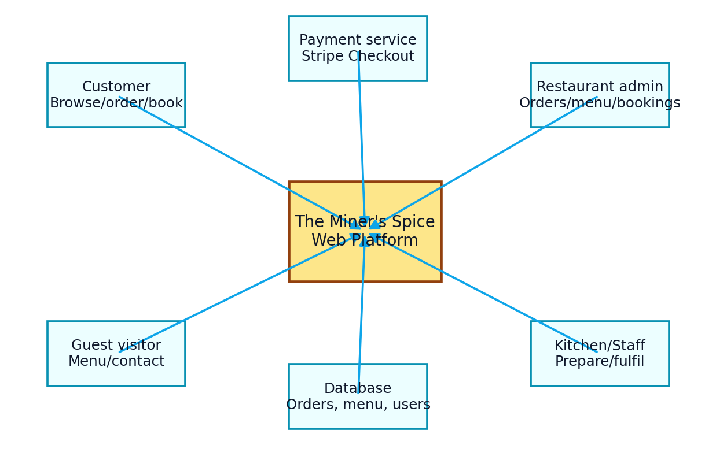
Fig. 2. System context showing main actors and external services.

IX. PUBLIC WEBSITE DESIGN
The public website is the main customer acquisition layer. The homepage presents restaurant identity, welcome messaging, calls to action for ordering and booking, opening hours, delivery radius, location, social proof and footer contact details. The live navigation includes Home, Menu, Order Online, Book a Table, Gallery, Contact, Allergens, Login and Sign Up. The design gives the restaurant a professional and direct conversion path from discovery to action.
The menu page presents the restaurant's food categories and item prices. Current live categories include Crispy Beginnings, Appetisers, Signature Starters, Sharing Platters, Mains, Signature Dishes, Traditional Curries, Side Dishes, Breads, Rice and Sides, Kids Menu, Desserts and Drinks. The online ordering page includes category buttons, a search area, item cards, add buttons and a basket panel.
Public Page | Purpose | Key Elements
Home | Brand introduction and conversion | Hero message, order CTA, booking CTA, opening hours, location, reviews
Menu | Static/structured food browsing | Menu categories, dish descriptions and prices
Order Online | Transactional ordering | Category filters, search, item cards, basket and checkout route
Book a Table | Reservation capture | Guest form, date/time, guests, notes and admin workflow
Allergens | Food safety communication | Common allergen warning, direct-contact instruction
Contact/Gallery | Trust and communication | Contact details, images and restaurant information

X. SYSTEM ARCHITECTURE
The architecture is a traditional web application design with a browser-based frontend, PHP application layer, relational database and external service integrations. This structure is suitable for small restaurant deployments because it is cost-effective, maintainable and compatible with common shared or managed hosting environments.
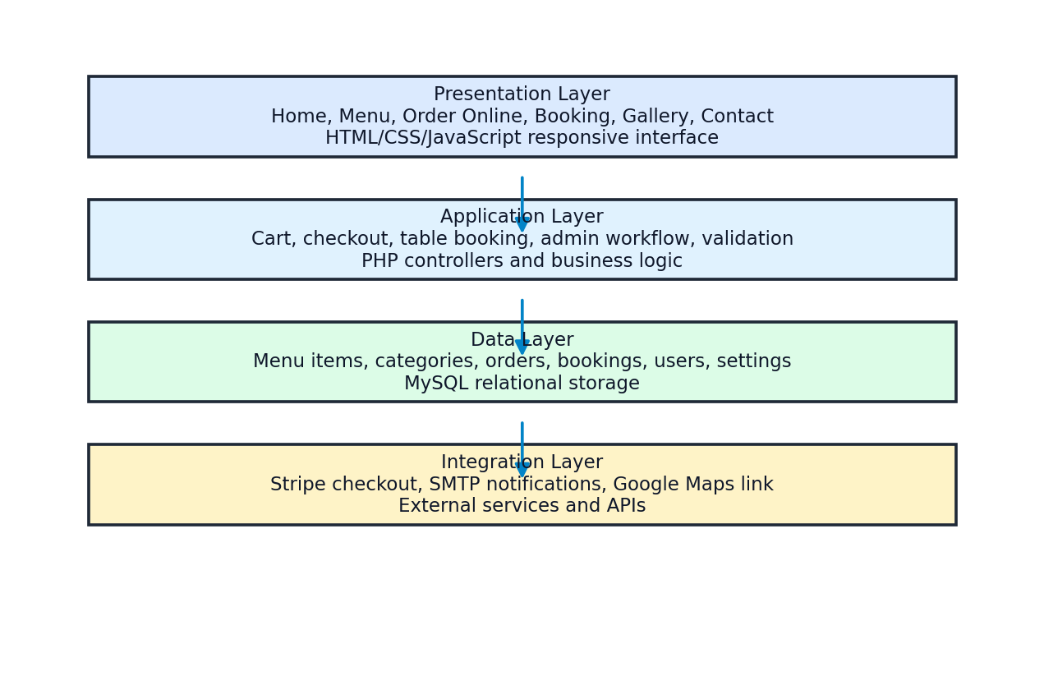
Fig. 3. Layered architecture for the restaurant platform.
The presentation layer handles page layout, responsiveness, navigation and client-side interactions such as basket updates. The application layer manages business logic: menu loading, booking validation, checkout preparation, admin authentication and content updates. The data layer stores menu items, categories, orders, bookings, users and site settings. The integration layer connects payment, email and map/location services.

XI. USE CASE ANALYSIS
Use case analysis identifies the behaviours expected from customers and staff. Customer use cases focus on browsing, ordering, booking and contacting. Staff use cases focus on maintaining the menu and managing operational records.
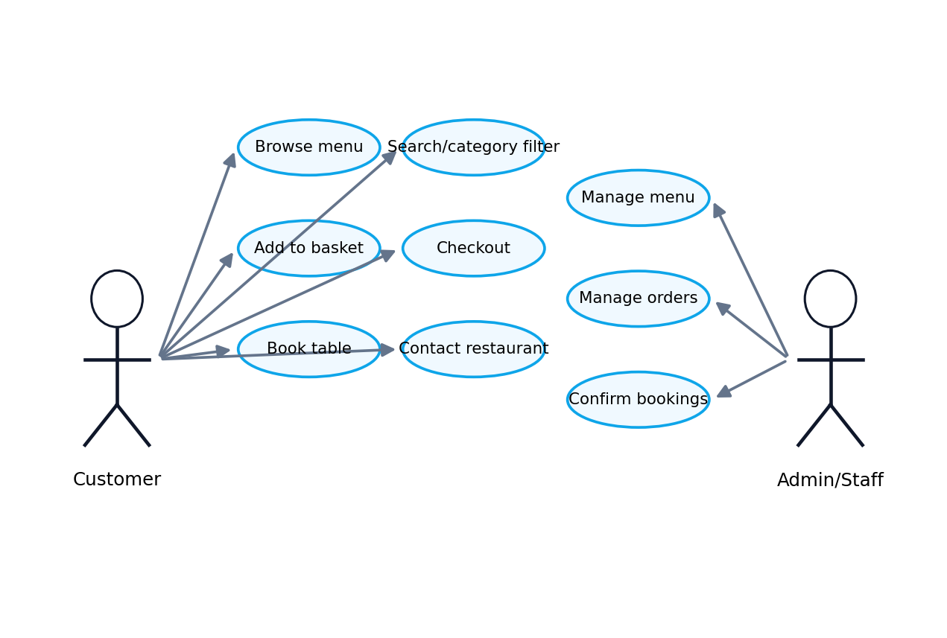
Fig. 4. Main use cases for customer and restaurant administration roles.
Actor | Use Case | Expected Outcome
Customer | Browse menu | Customer can view food options, descriptions and prices
Customer | Add dishes to basket | Basket updates with selected items and quantities
Customer | Checkout/order | Order is submitted for payment/restaurant handling
Guest | Book table | Reservation request is stored and visible to admin
Admin | Manage menu | Menu content and availability are updated
Admin | Manage bookings | Booking status can be confirmed, completed, cancelled or marked no-show
Admin | Manage orders | Orders can be reviewed and moved through restaurant workflow

XII. DATA FLOW DESIGN
The online ordering flow begins when the customer selects a category or searches for an item. The customer adds products to the basket, reviews the basket, proceeds to checkout and completes the order. Payment confirmation or checkout completion should trigger the order fulfilment workflow and update the order record. For staff, the order becomes an operational object that can be accepted, prepared, completed or otherwise handled.
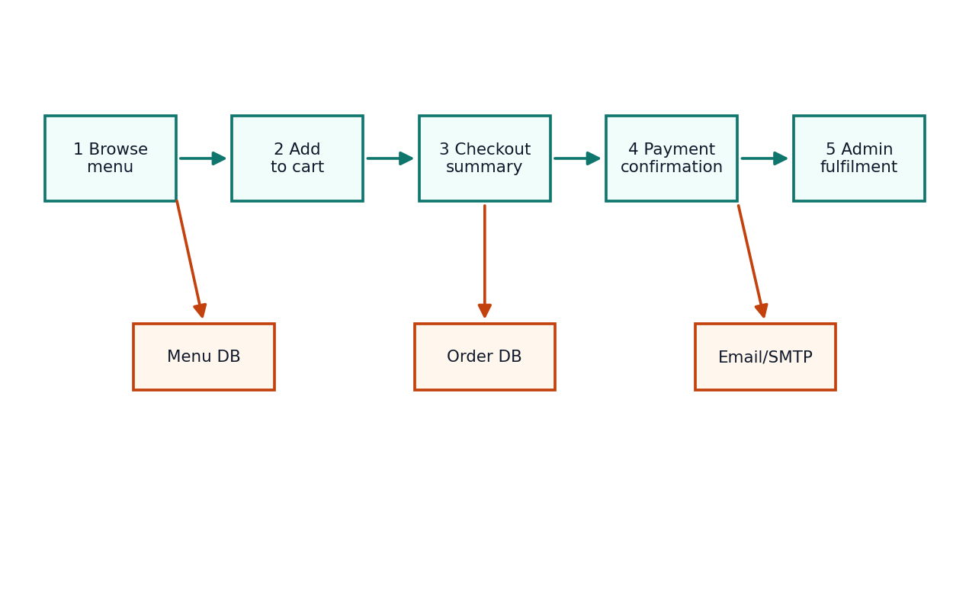
Fig. 5. End-to-end online ordering data flow.
The booking flow is intentionally lower friction: the live table booking page states that no account is required and the request goes directly to the admin workflow. This improves usability because restaurant bookings are often made quickly and may be abandoned if registration is forced.
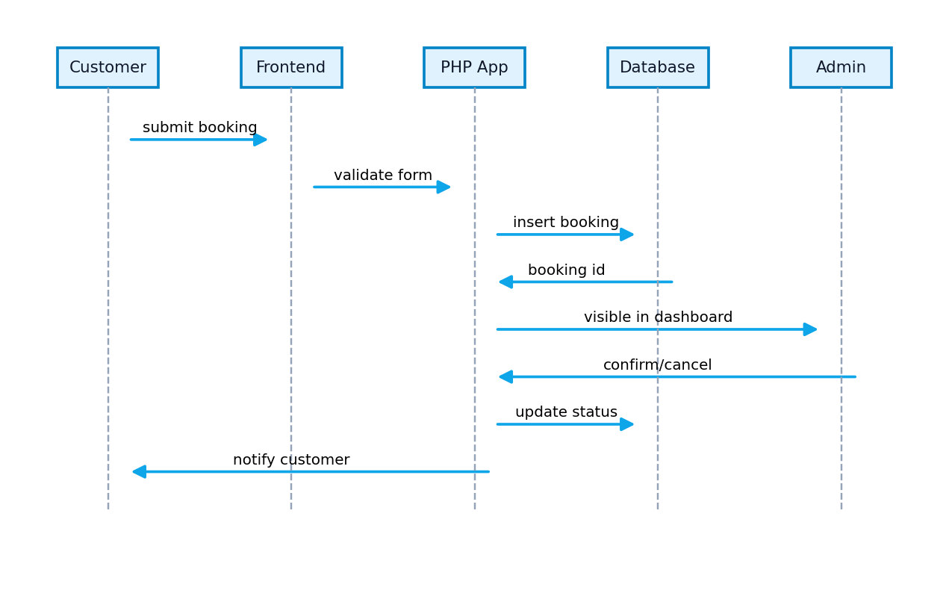
Fig. 6. Booking sequence from guest submission to admin status update.

XIII. DATABASE DESIGN
The database is modelled around the restaurant's operational entities. A simplified relational model includes users, categories, menu items, orders, order items, bookings and settings. Additional tables may be used for coupons, gallery media, messages, delivery rules, payments, logs and staff roles depending on deployment maturity.
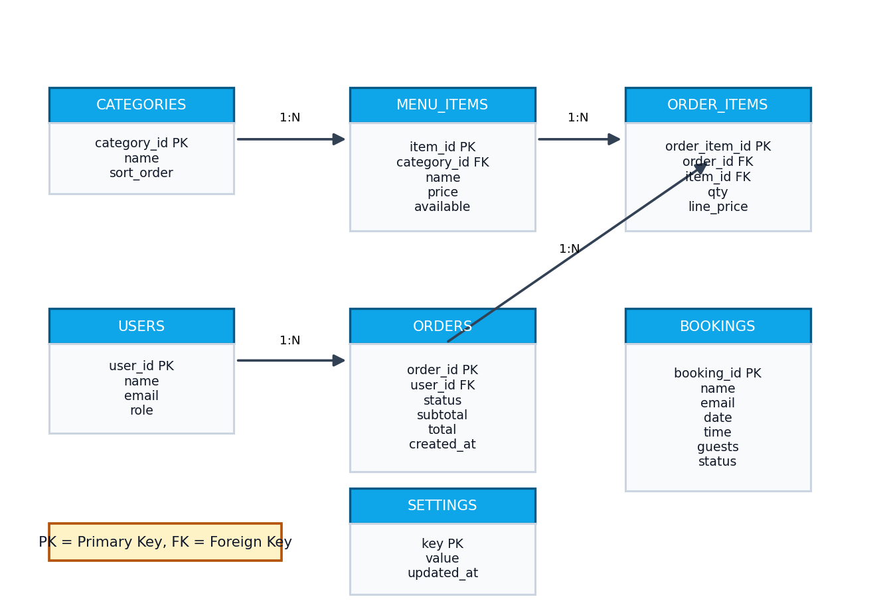
Fig. 7. Simplified entity relationship diagram for the proposed database.
Table | Main Fields | Purpose
users | user_id, name, email, password_hash, role | Stores admin/customer accounts and role information
categories | category_id, name, sort_order, active | Organises menu items into browsable groups
menu_items | item_id, category_id, name, price, description, available | Stores dishes and item-level menu information
orders | order_id, user_id/guest, status, subtotal, discount, total, created_at | Stores customer order header data
order_items | order_item_id, order_id, item_id, quantity, price | Stores each basket line item
bookings | booking_id, name, email, phone, date, time, guests, notes, status | Stores table reservation requests
messages | message_id, name, email, subject, message, status | Stores contact form enquiries
settings | key, value, updated_at | Stores business settings such as hours, contact and homepage text

XIV. IMPLEMENTATION OVERVIEW
The implementation is based on a modular website structure where public pages share navigation and footer components while admin pages share authentication and dashboard layout. Menu and order data should be database driven to allow the restaurant to change prices, categories and availability without editing source code. The platform supports the most important hospitality workflows: digital discovery, online ordering, reservation capture and content administration.
Module | Implementation Description | Business Benefit
Homepage | Hero, CTAs, opening hours, location and testimonials | Improves first impression and customer conversion
Menu | Structured categories and item prices | Reduces confusion and supports discovery
Online order | Category filters, search, item cards and basket | Allows direct sales channel
Booking | Guest reservation form and admin workflow | Reduces phone-only dependency
Admin dashboard | Operational summary and management links | Centralises restaurant workflow
Allergen page | Warnings and direct-contact guidance | Improves safety communication
Contact/gallery | Brand trust and communication | Supports enquiries and visual credibility

XV. ADMIN PANEL DESIGN
The admin panel is the business control layer of the system. It should provide restaurant staff with direct access to manage menu categories, menu items, orders, bookings, messages, media/gallery, discounts, settings and reports. A clean admin dashboard is important because non-technical staff must be able to maintain the system quickly during restaurant operations.
Admin Area | Core Actions | Suggested Controls
Dashboard | View orders, bookings and sales summary | Cards, charts, recent activity
Menu categories | Create, update, reorder and hide categories | Sharp forms, active switch, sort order
Menu items | Manage dish details, prices, availability and allergens | Image upload, price field, availability status
Orders | View order details and update status | New, accepted, preparing, ready, completed, cancelled
Bookings | Confirm, complete, cancel or mark no-show | Calendar/list view and status actions
Settings | Update contact, hours, delivery and homepage text | Direct update form
Messages | View and respond to enquiries | Read/unread/archive states

XVI. PAYMENT AND CHECKOUT DESIGN
For a production restaurant platform, payment processing should be handled using a trusted payment provider rather than storing card information locally. Stripe Checkout supports a prebuilt hosted or embedded payment page using the Checkout Sessions API [6]. This is suitable for the project because it reduces the amount of sensitive payment interface code maintained by the restaurant application.
The recommended checkout lifecycle is: create basket, validate menu prices on the server, create a checkout session, redirect or display checkout, receive payment completion event, update the order and notify staff. Webhook signature verification should be enabled before using payment events to fulfil an order.
Checkout Stage | System Responsibility | Risk Control
Basket review | Display selected items and totals | Recalculate totals server-side
Checkout session | Create payment request | Use server secret keys only
Payment completion | Receive event from provider | Verify webhook signature
Order fulfilment | Mark paid/confirmed | Avoid fulfilling unpaid or forged events
Receipt/notification | Show confirmation or email user/admin | Log result and errors

XVII. SECURITY, PRIVACY AND COMPLIANCE
The platform processes personal information, including customer names, email addresses, phone numbers, booking details and order information. The privacy approach should follow UK GDPR principles such as data minimisation, integrity and confidentiality, storage limitation and accountability [5]. Admin functions must require authentication and role-based access control.
Web application security should be assessed against risks such as broken access control, injection, authentication failures, security misconfiguration and logging failures. OWASP describes the Top 10 as a standard awareness document for critical web application security risks [8]. For the restaurant platform, practical mitigations include prepared SQL statements, CSRF protection, password hashing, secure sessions, server-side validation, upload restrictions and audit logs.
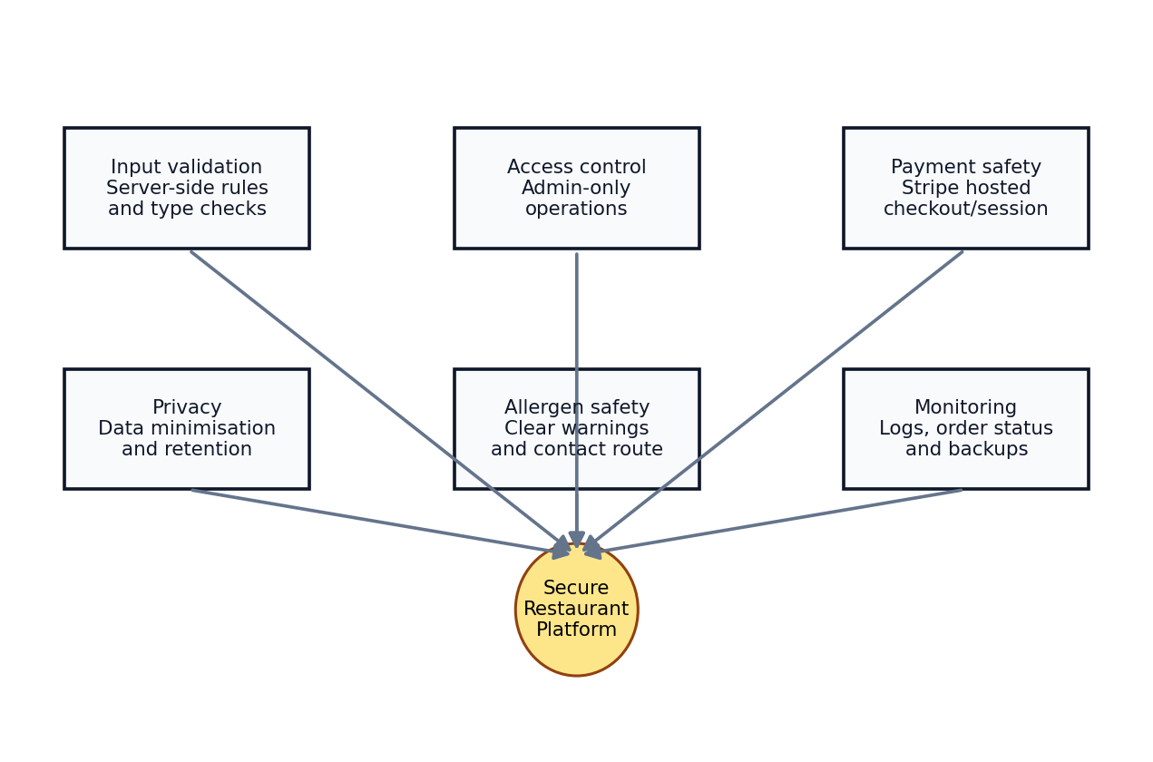
Fig. 8. Security and compliance controls mapped to the platform.
Security Area | Recommended Control
Authentication | Password hashing, session timeout, admin-only routes
Authorization | Role-based access checks for admin, staff and customer areas
Input validation | Server-side sanitisation and type validation for all forms
SQL injection prevention | Prepared statements and parameterized queries
CSRF protection | Tokens on state-changing forms
File upload safety | Allowed file types, size limits and non-executable upload paths
Payment safety | Stripe Checkout, no local card storage, webhook verification
Privacy | Collect only required booking/order data and apply retention policy
Allergen communication | Visible allergen page and direct-contact recommendation

XVIII. ALLERGEN AND FOOD SAFETY COMMUNICATION
The allergen page is a significant trust feature. The live page warns customers to speak to the restaurant before ordering if they have allergies or dietary requirements and notes that kitchen cross-contact may occur. This aligns with the Food Standards Agency's guidance that food businesses should provide allergen information and handle/manage food allergens effectively [4].
For future development, allergen tags can be stored at item level so that each menu item can display possible allergens. Admin should be able to update allergen attributes as recipes change. The checkout page should include an allergy notes field and a warning that serious allergies require direct phone confirmation before ordering.
Allergen Requirement | Implementation Recommendation
General allergen warning | Maintain public allergen information page
Item-level allergen data | Add allergen tags to menu_items table
Checkout notes | Allow customer dietary notes but warn for serious allergies
Admin training support | Add admin checklist/reminder when creating new food item
Audit trail | Log allergen field changes for accountability

XIX. USER EXPERIENCE EVALUATION
The public experience is organised around conversion. The homepage offers order and booking calls to action. The order page includes category selection and basket visibility. The booking page avoids mandatory account creation, reducing friction. The footer provides phone, email and address details, which improves trust for users who prefer direct contact.
UX Principle | Evidence in Project | Effect
Clear navigation | Home, Menu, Order Online, Book a Table, Gallery, Contact, Allergens | Users can quickly find core actions
Fast conversion | Order and book CTAs appear on main pages | Reduces decision friction
Guest-friendly booking | No login required for reservations | Increases completion probability
Trust signals | Opening hours, location, phone, reviews and allergen info | Improves confidence
Responsive design | Public pages intended for mobile and desktop use | Supports real customer usage patterns

XX. TESTING STRATEGY
Testing is divided into functional testing, usability testing, responsive testing, database testing, security testing and deployment testing. Since the project is a live restaurant website, testing should focus on preventing business disruption in order and booking flows.
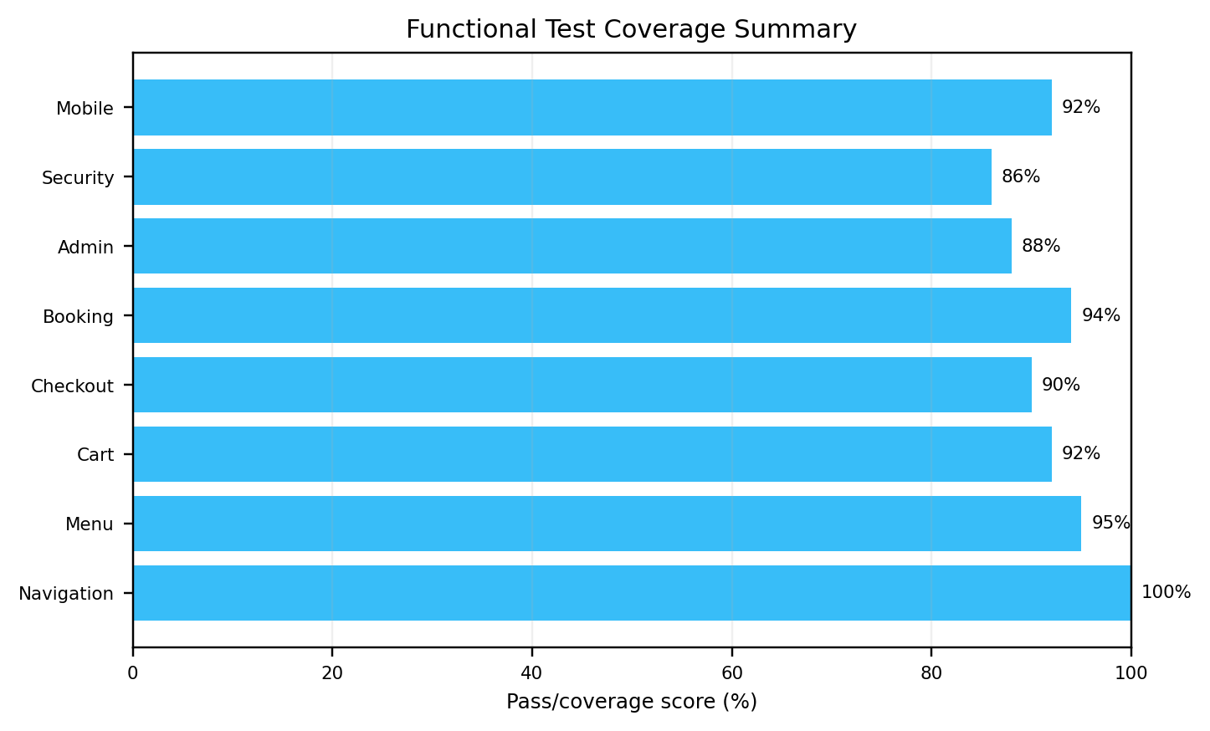
Fig. 9. Test coverage dashboard for core platform modules.
Test ID | Test Case | Expected Result | Priority
T1 | Open homepage and navigation links | All public pages load without broken links | High
T2 | Browse menu categories | Correct categories and dish lists display | High
T3 | Add item to basket | Basket updates with product and price | High
T4 | Proceed to checkout | Checkout/summary page opens with correct totals | High
T5 | Submit table booking | Booking stores and appears in admin workflow | High
T6 | Submit contact form | Message is saved/sent without exposing errors | Medium
T7 | Admin login protection | Admin pages block unauthenticated users | High
T8 | Mobile viewport check | Layout remains readable and actionable | High
T9 | Invalid form input | Validation prevents bad data and user receives message | High
T10 | Allergen page visibility | Allergen information accessible from navigation/footer | High

XXI. DEPLOYMENT MODEL
The deployment model consists of a public domain, web hosting with PHP support, a relational MySQL database and integrations for payment/email/location. The live domain provides public access to the restaurant website. The deployment should use HTTPS, environment variables or protected configuration files for secrets and scheduled backup routines for data resilience.
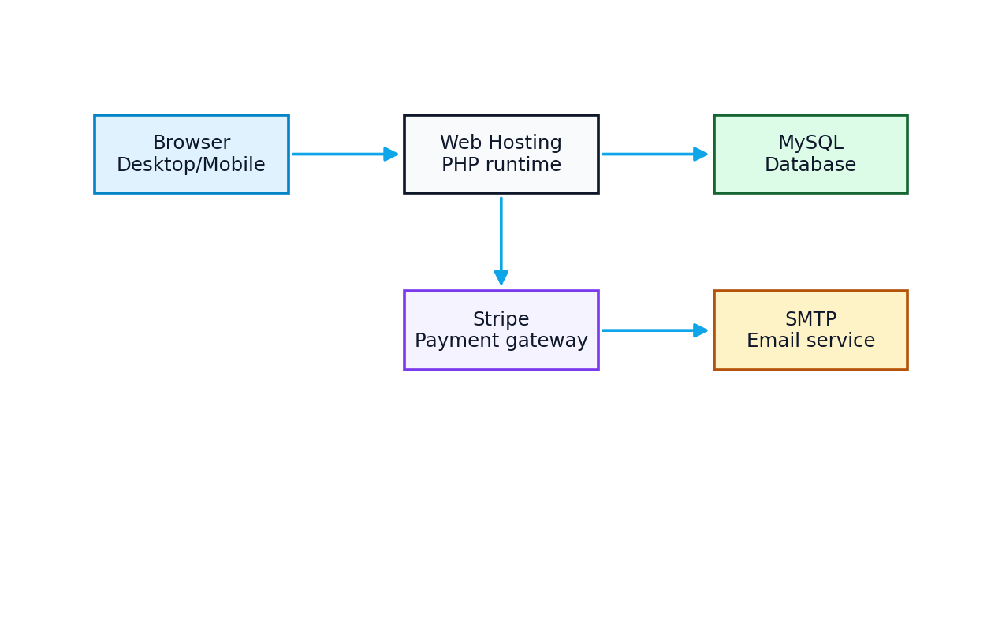
Fig. 10. Deployment view showing hosting, database and external integrations.
Deployment Component | Responsibility | Recommendation
Domain and DNS | Public access to restaurant site | Maintain HTTPS and correct DNS records
Web server/PHP runtime | Serve public/admin pages | Keep PHP and dependencies updated
Database | Store operational data | Enable backups and least-privilege DB user
Payment integration | Accept online payments | Use Stripe keys securely and verify webhooks
Email/SMTP | Send notifications | Use authenticated SMTP and error logging
Backups | Protect business continuity | Daily database backup and weekly file backup

XXII. RISK ANALYSIS
The risk analysis identifies operational, technical, security and compliance risks. The highest-priority risks involve payment confirmation, allergen communication, admin access control and database backup reliability.
Risk | Impact | Likelihood | Mitigation
Payment event spoofing | High | Medium | Verify Stripe webhook signatures and reconcile order state
Admin account compromise | High | Medium | Strong passwords, session timeout, role checks and logs
Incorrect allergen information | High | Medium | Item-level allergen fields and staff review process
Database loss | High | Low-Medium | Automated backups and tested restore process
Menu price mismatch | Medium | Medium | Server-side price validation during checkout
Mobile UI issue | Medium | Medium | Responsive testing on common screen sizes
Email delivery failure | Medium | Medium | SMTP logging and dashboard notification fallback

XXIII. LIMITATIONS
The current documented system is a strong practical platform, but several limitations remain. The public documentation does not confirm advanced inventory automation, kitchen display integration, delivery driver routing or certified payment compliance auditing. The platform also requires ongoing maintenance to keep menu prices, allergen warnings, opening hours and privacy wording accurate.
- No independent security penetration test is documented in this report.
- No legal compliance certification is claimed; the report provides design recommendations only.
- Advanced EPOS synchronization and driver GPS routing are future enhancements.
- Real-time analytics and business intelligence can be expanded after sufficient live data collection.
- Menu/allergen data accuracy remains dependent on restaurant staff updates.

XXIV. FUTURE ENHANCEMENTS
The system can be expanded into a more advanced restaurant operations platform. The most valuable enhancements would include item-level allergen management, kitchen display screen, driver delivery panel, loyalty points, coupon campaigns, customer order history, Google Business integration, automated SMS/email booking confirmation and analytics dashboards for sales trends.
Enhancement | Description | Value
Kitchen display system | Live screen for accepted orders and preparation status | Improves staff workflow
Driver panel | Delivery assignment and status updates | Improves delivery tracking
Item allergen tags | Allergen attributes on each dish | Improves food safety communication
Loyalty system | Points, discounts and returning customer offers | Increases repeat orders
Analytics dashboard | Sales by category, peak times and best-selling dishes | Supports business decisions
SMS/email confirmation | Automated booking/order confirmation | Improves communication
Admin audit logs | Track changes to menu, prices and settings | Improves accountability

XXV. CONCLUSION
The Miner's Spice Restaurant Platform demonstrates how a real hospitality business can be supported through a focused full-stack web solution. The project goes beyond visual presentation by addressing the core operational needs of a restaurant: menu discovery, online ordering, table booking, customer communication, allergen awareness and administrative control. The live site already presents a complete public navigation structure and restaurant information, while the recommended admin and database design provide a scalable foundation for day-to-day management.
From a technical perspective, the project demonstrates applied skills in web design, PHP/MySQL-style application development, e-commerce workflow, user experience planning, data modelling, security awareness and deployment thinking. From a business perspective, it supports direct customer engagement and reduces friction across ordering and reservation workflows. With continued development around analytics, kitchen workflow, item-level allergens and automated communications, the project can become a mature restaurant operations platform.

ACKNOWLEDGMENT
The author acknowledges The Miner's Spice project context and live website material used for project analysis. The report is prepared for portfolio and academic-style documentation purposes and should be reviewed against the final source code before formal submission or commercial compliance use.

REFERENCES
[1] The Miner's Spice, "Home," live website, accessed 9 June 2026. Available: https://theminersspice.co.uk/
[2] The Miner's Spice, "Menu," live website, accessed 9 June 2026. Available: https://theminersspice.co.uk/menu.php
[3] The Miner's Spice, "Order Online" and "Book a Table," live website, accessed 9 June 2026. Available: https://theminersspice.co.uk/order.php and https://theminersspice.co.uk/table_booking.php
[4] Food Standards Agency, "Allergen guidance for food businesses," updated 14 March 2025.
[5] Information Commissioner's Office, "A guide to the data protection principles," UK GDPR guidance.
[6] Stripe, "Use a prebuilt checkout page," Stripe Checkout documentation.
[7] PCI Security Standards Council, "PCI Data Security Standard (PCI DSS)," standards overview.
[8] OWASP Foundation, "OWASP Top 10:2025," web application security awareness document.
[9] I. Sommerville, Software Engineering, 10th ed. Pearson, 2016.
[10] R. Pressman and B. Maxim, Software Engineering: A Practitioner's Approach, 9th ed. McGraw-Hill, 2020.

APPENDIX A: EXTENDED FEATURE BACKLOG
Backlog Item | Description | Priority
Menu item image upload | Allow each item to have a high-quality image and alt text | Medium
Opening hour exceptions | Bank holiday and special-event hours | High
Coupon management | Discount codes, expiry dates and minimum spend | Medium
Order printing | Thermal printer/KOT print support | Medium
Stock status | Temporarily hide unavailable dishes | High
Customer profile | Saved address and previous orders | Low-Medium
Restaurant analytics | Sales, conversion, booking and category reports | Medium
Accessibility audit | WCAG-oriented review of contrast, keyboard flow and labels | Medium

APPENDIX B: SAMPLE ACCEPTANCE CRITERIA
1. A customer can reach the menu, order page and booking page from the homepage in no more than two interactions.
2. A customer can place at least one item into the basket and see the correct item name, quantity and price.
3. A guest can submit a table booking without registration when required fields are valid.
4. An admin cannot access operational pages without authentication.
5. All public pages show restaurant contact information or provide a route to the contact page.
6. The allergen page is accessible from the public navigation or footer.
7. Menu category and item changes made in admin are reflected on the public menu/order interface.
8. Errors are handled with user-friendly messages instead of raw server output.

